|  |  |  |  |  |  |  |
| --- | --- | --- | --- | --- | --- | --- |
| **Today's Date:** | 7/23/2021 | | | | | |
| **Well Name:** | DAVIS GAS UNIT 1 | **Location:** | Sec: 04 | Twn: 033N | Rng: 010W | UL: C |
| **API Number:** | 05.067.06524 | **Footage:** | 1058' FNL & 1599' FWL | | | |
| **Operator:** | Hilcorp Energy Company | **Area/Run/MSO:** | 01 | 0101 | Bob Percell | |
| **Meter #:** | 06633044 | | **Pipeline:** | HEC | | |
|  | | | | | | |
| **INC Number:** | 693903451 | **Agency:** | COGCC | **Inspector:** | Catherine Roy | |
| **Type of INC:** | Written | **Photos Required:** | **Yes** | **Due Date:** | **8/5/2021** | |
| **Issue of Concern:** | Comment: Stained soils, up to 2 feet in diameter, observed south of the wellhead.  Corrective Action: -Properly dispose of oily waste in accordance with 905.e. by 8/5/2021. Date: 08/05/2021  See attached document and photos | | | | | |

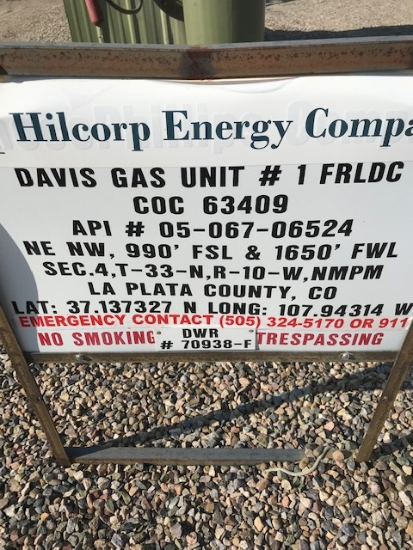

Soil stains removed from ground around well head.

