Complaint Form Template

Complaint #: 200435969

Field Inspector Assigned: Gomez, Jason

Complaint Received:

Date: 7/23/2015 Time (Military): 0800Hrs

Contacted by Inspector:

Date: Time (Military):

Well Number: 05-Choose an item.-Click here to enter text. Location #: 441566

Inspection Document #: 673802354

Complainant: Catherine Baird Phone:

Address:

Nature of complaint: Noise/Dust/Access

Field Inspector Actions:

On 7/23/2015 I was contacted by Jeff Rickard of the COGCC in reference to a complaint of noise and dust mitigation and access restrictions at the Troudt Extraction location.

I went to the location and performed a site inspection see Doc# 673802354 for details of inspection and photos. Upon arrival at the location I observed the site was currently in the process of installing 30’ sound walls on the west end of location and the operator was in the process of drilling conductor pipe on location. I observed a farmer to the north of the location tilling his field which appeared to be causing dust from the west of the location but I did not observe any dust coming from the location. (See Attached photos)

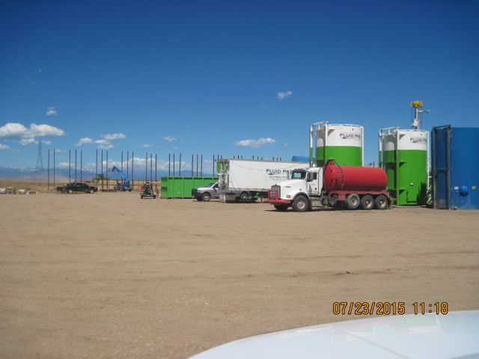

I spoke to Jose Torres from Extraction on location and advised him of the issues raised by the complainant. Jose said Extraction was in the process of installing the sound walls and as far as he was aware all the traffic to and from the location
were being routed to the north on county road 17. Extraction indicated they would install sign to control the traffic and they would be bringing in a water truck to control any possible dust mitigation.

I performed sound study approx 350’ to the east of location. See inspection Doc# 673802354 for results of sound study.

The traffic issues raised by the complainant as well as the dust mitigation issues were turned over to weld county representative Troy Swain.

Summary:

Upon inspection no violations of COGCC rules were observed.

